**Vancouver Hosts and Listings Analysis**

a. Analyse different metrics to draw the distinction between Super Host and Other Hosts:

To achieve this, you can use the following metrics and explore a few yourself as well.

Acceptance rate, response rate, instant booking, profile picture, identity verified, review

scores, average no of bookings per month, etc.

--Acceptance Rate

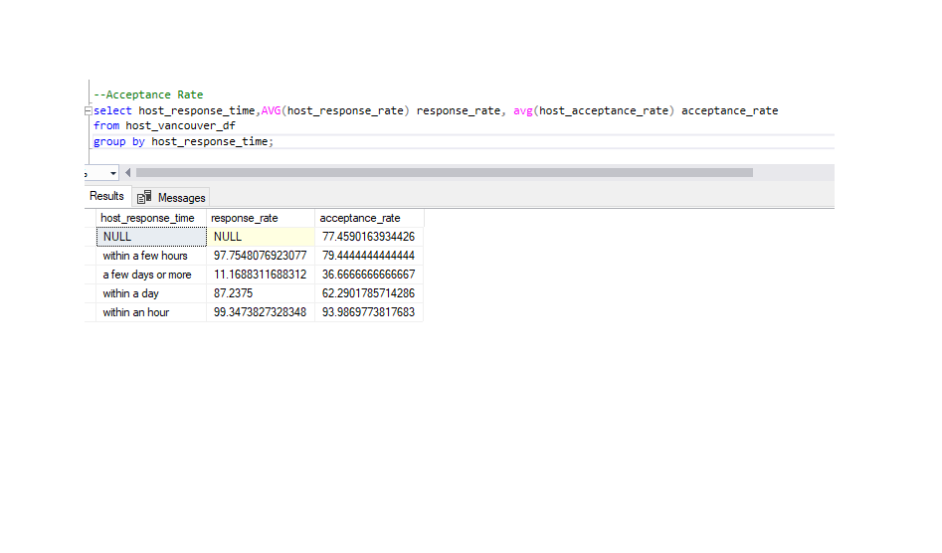

--Response Rate

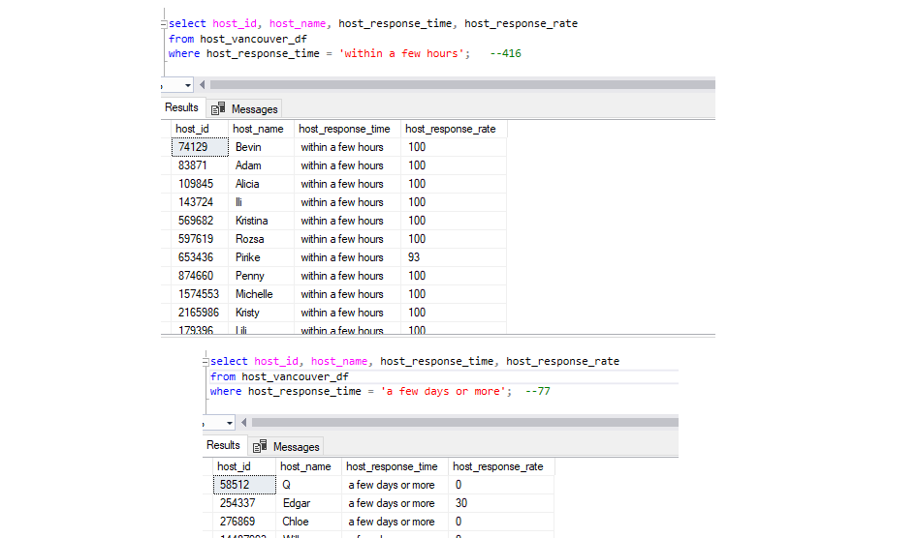

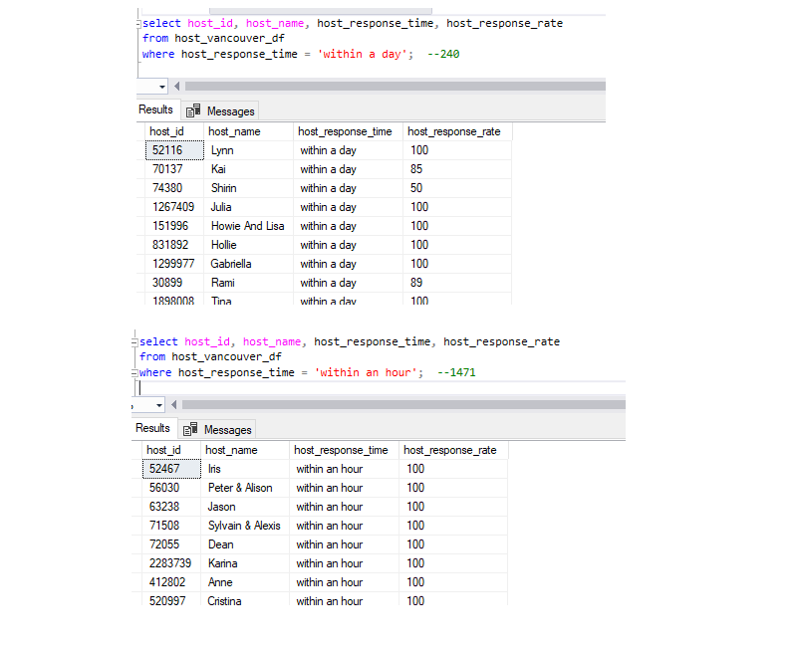

--Instant Bookable

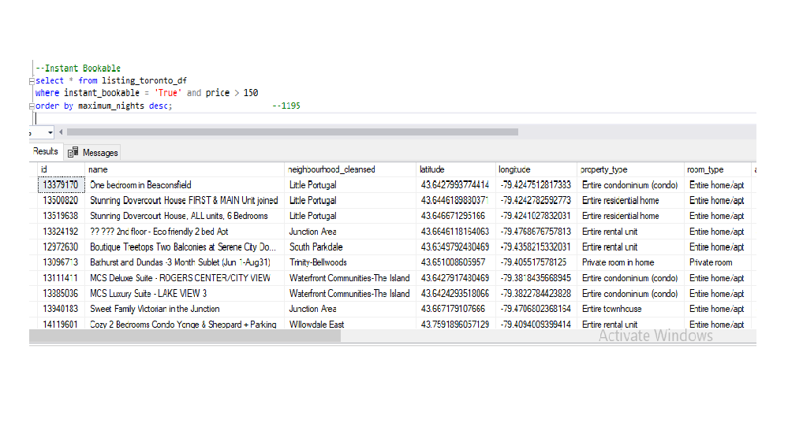

--Profile Picture

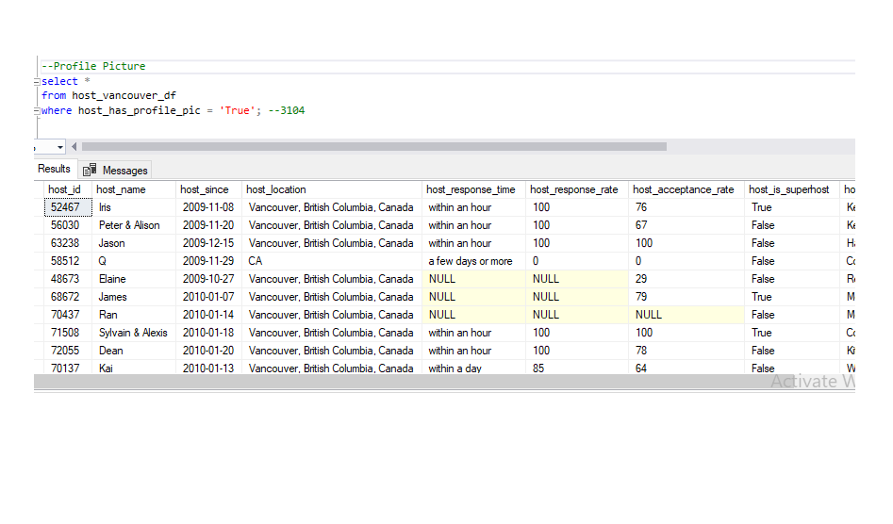

--Identity verified

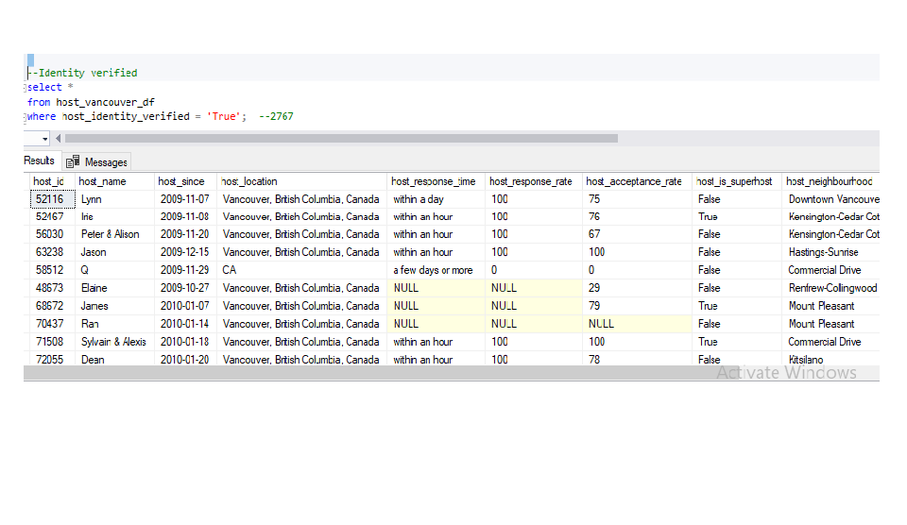

--Is Super host

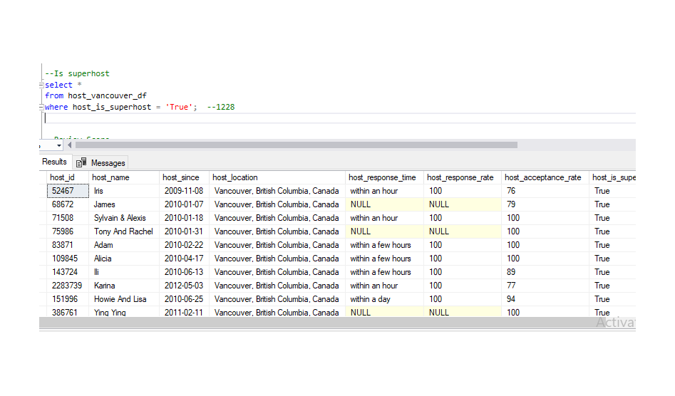

--Review Score

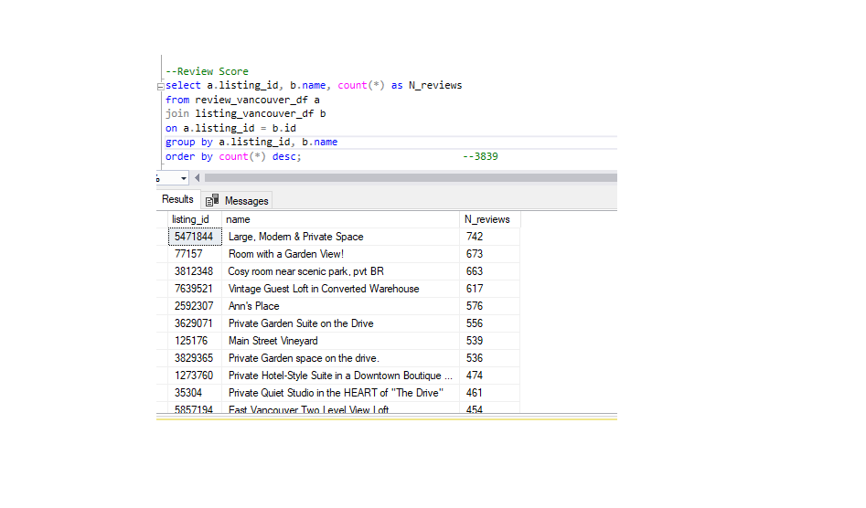

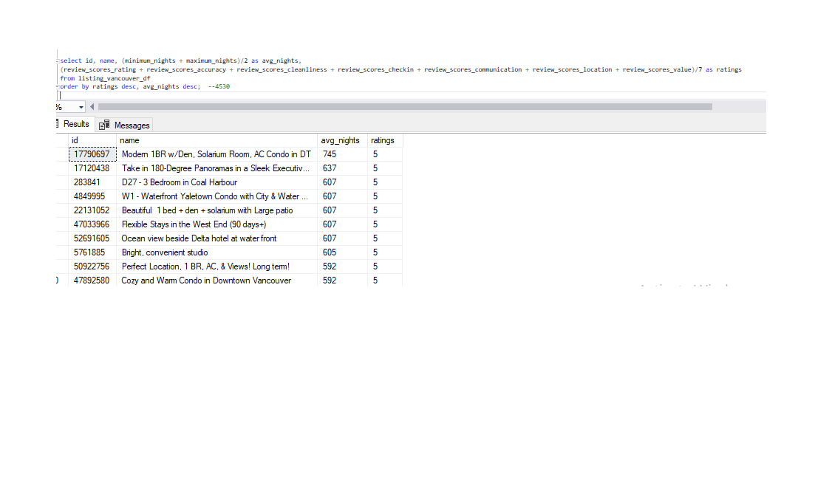

--Bookings per month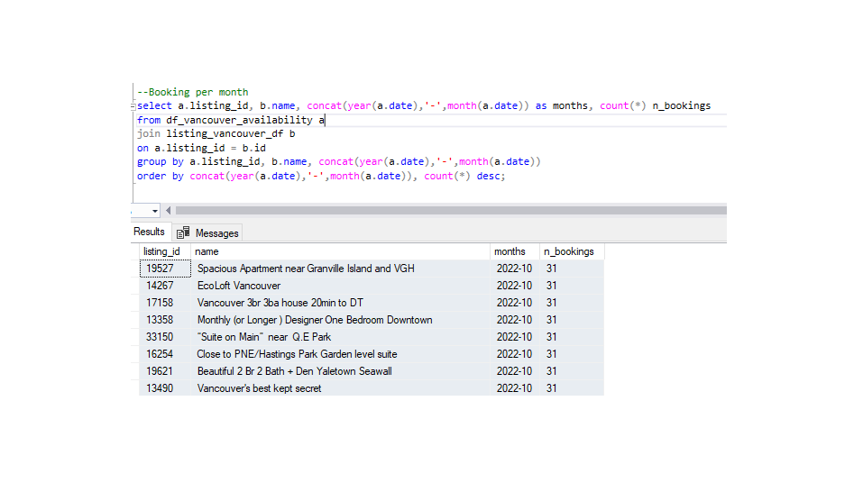

b. Using the above analysis, identify top 3 crucial metrics one needs to maintain to become a

Super Host and also, find their average values.

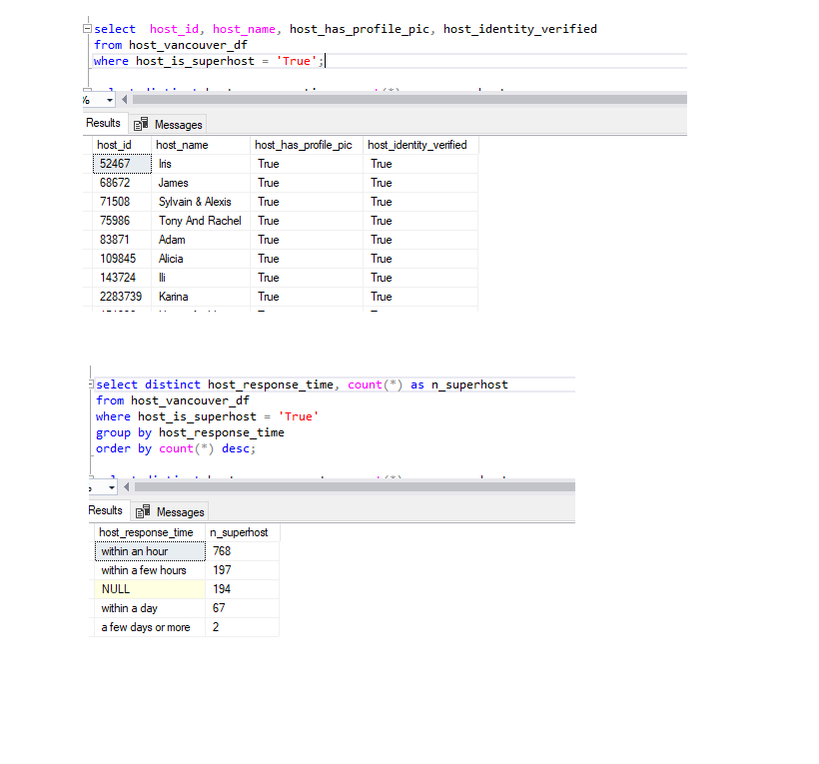

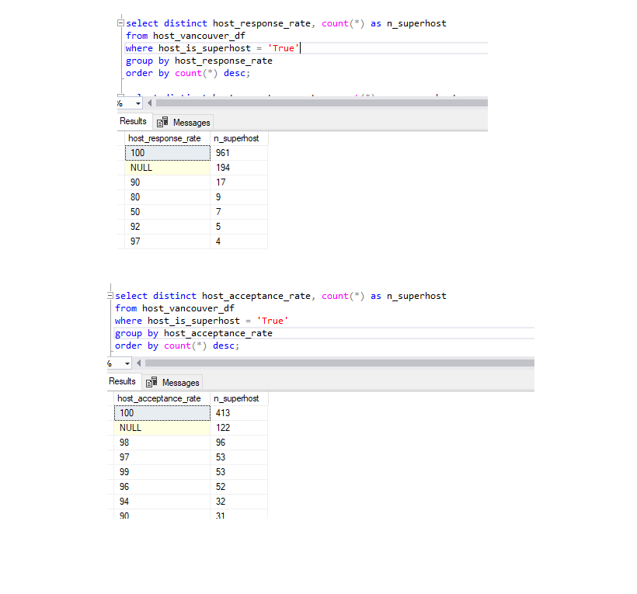



c. Analyse how does the comments of reviewers vary for listings of Super Hosts vs Other Hosts

(Extract words from the comments provided by the reviewers)

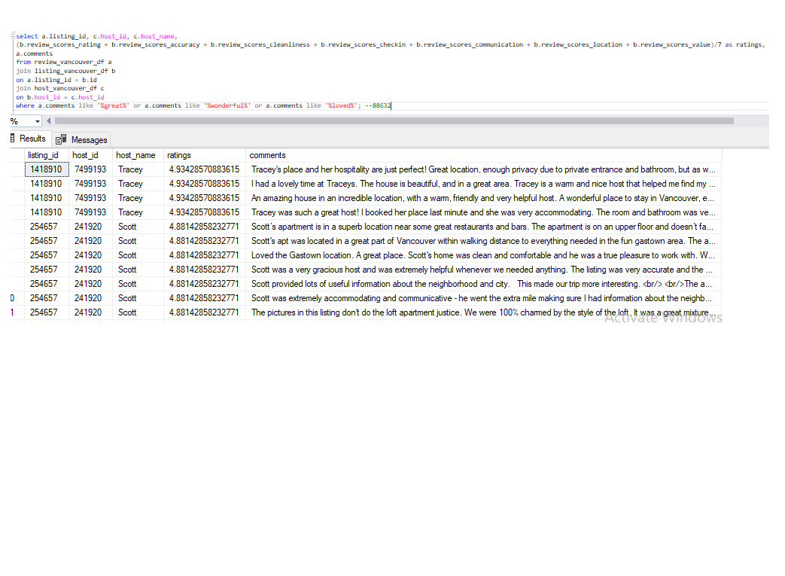

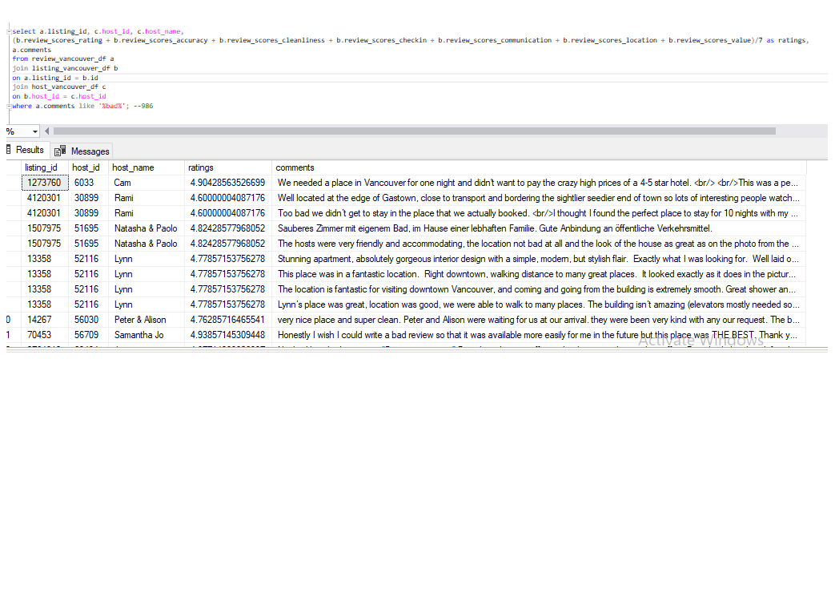

d. Analyse do Super Hosts tend to have large property types as compared to Other Hosts.

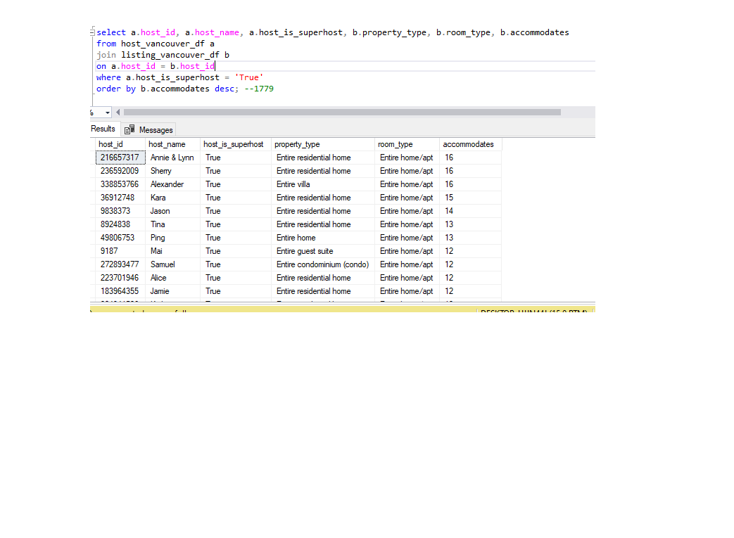

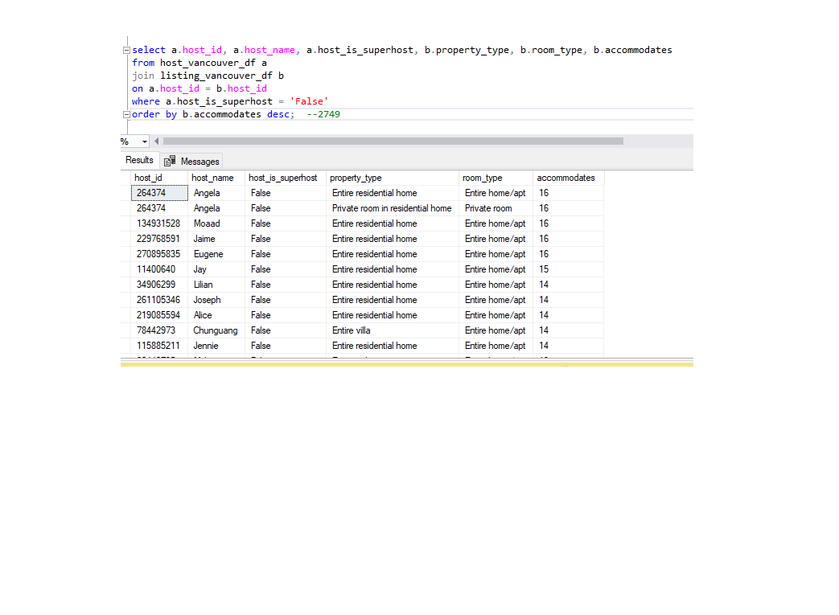

Observation: Cannot say that super hosts hold large properties.

e. Analyse the average price and availability of the listings for the upcoming year between Super

Hosts and Other Hosts.

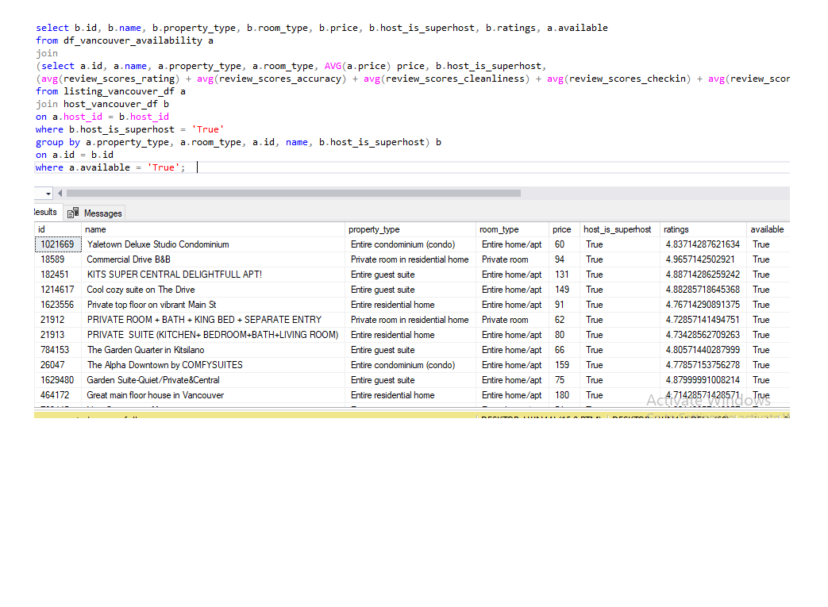

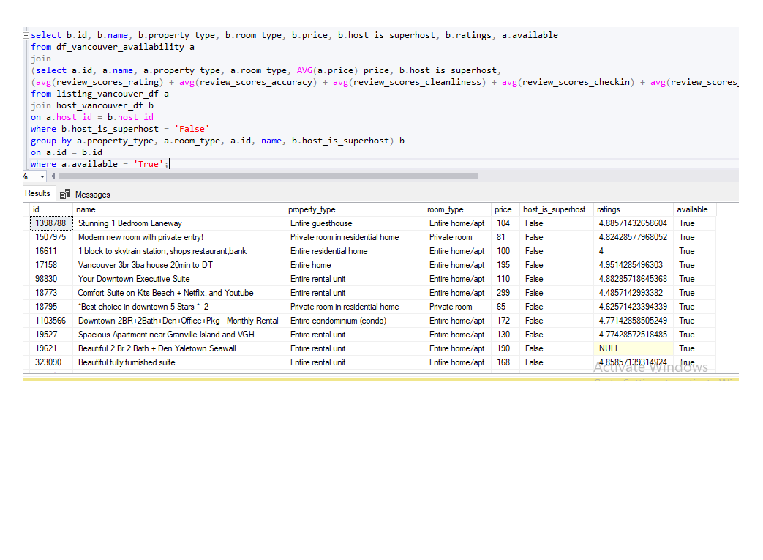

**Toronto Hosts and Listings Analysis**

a. Analyse different metrics to draw the distinction between Super Host and Other Hosts:

To achieve this, you can use the following metrics and explore a few yourself as well.

Acceptance rate, response rate, instant booking, profile picture, identity verified, review

scores, average no of bookings per month, etc.

--Acceptance Rate

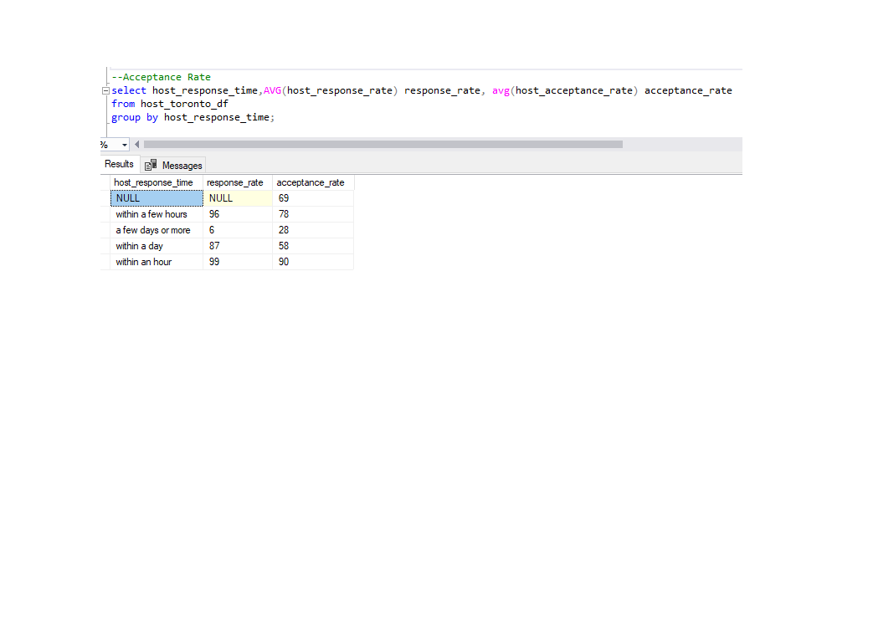

--Response Rate

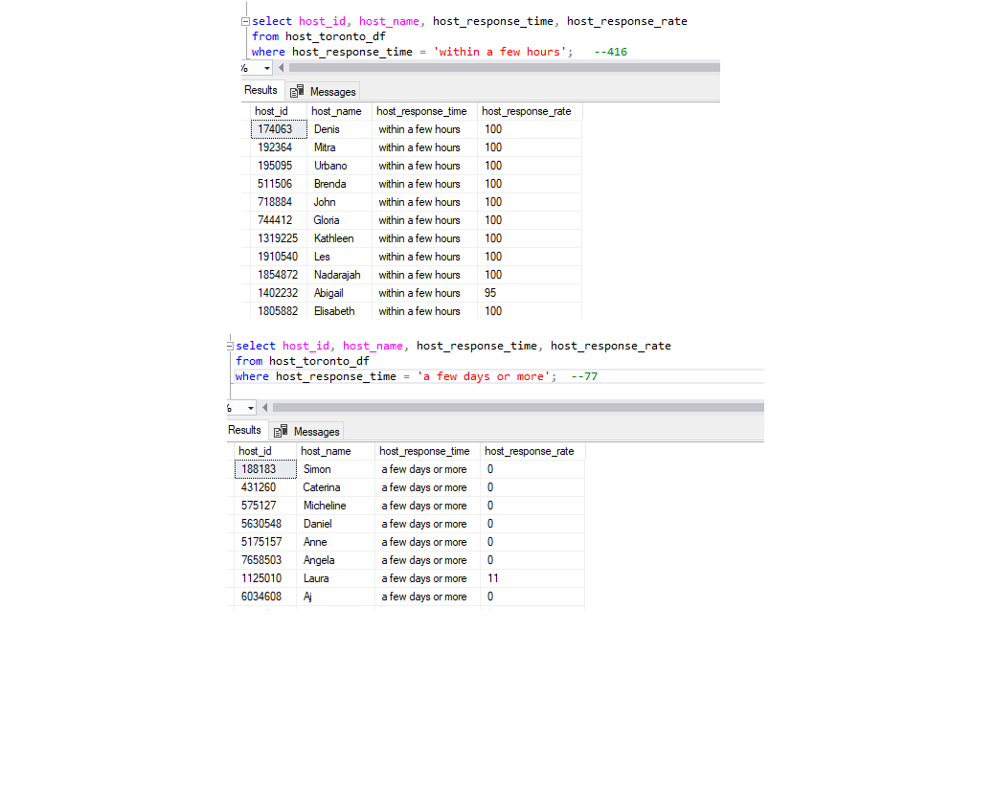

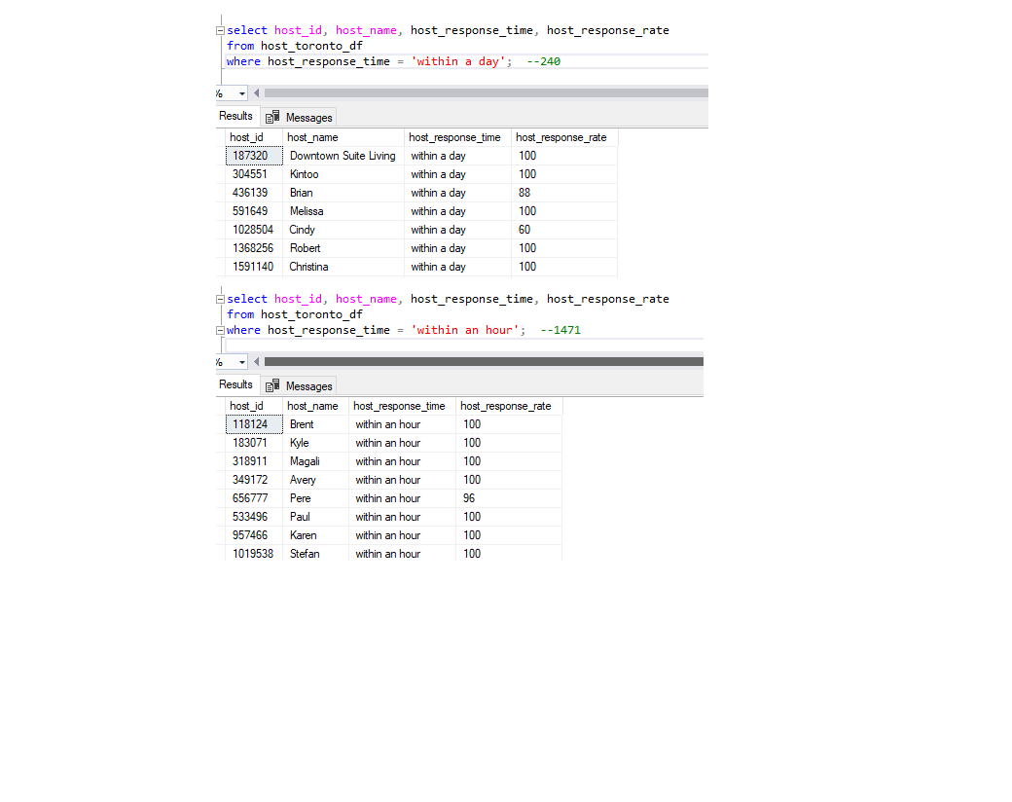

--Instant Bookable 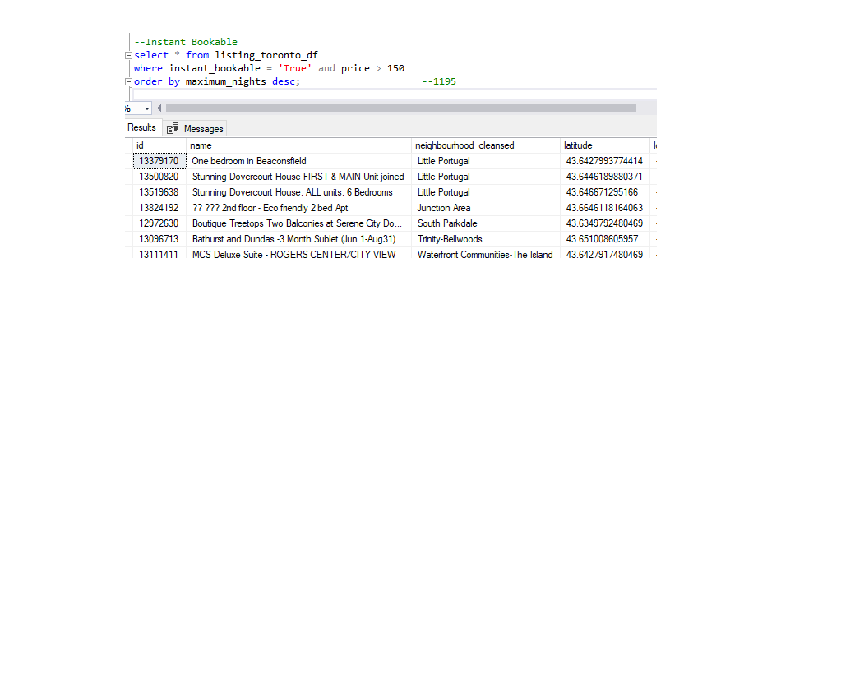

--Profile Picture 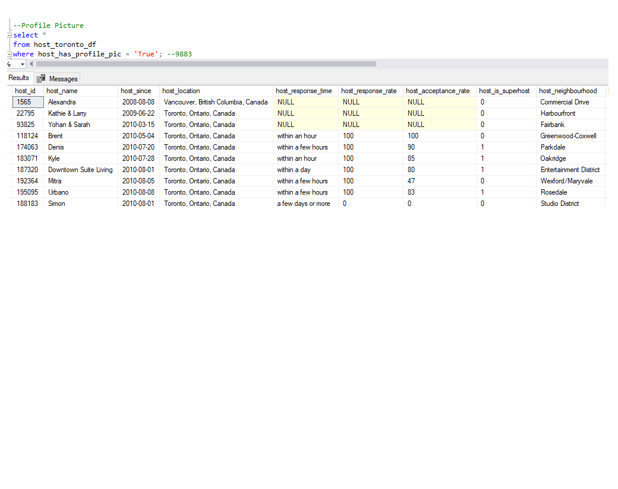

--Identity verified

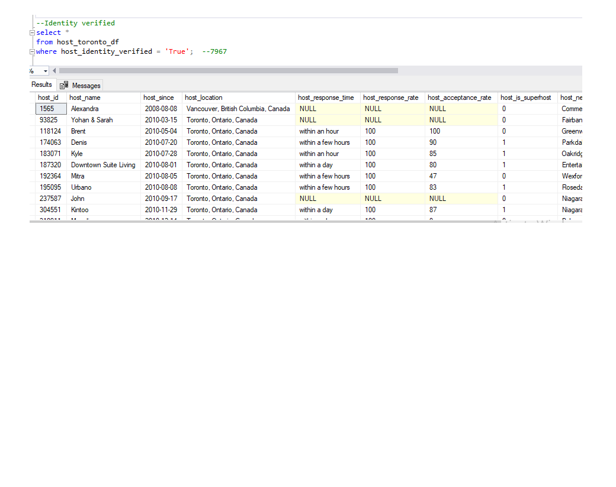

--Is Super host

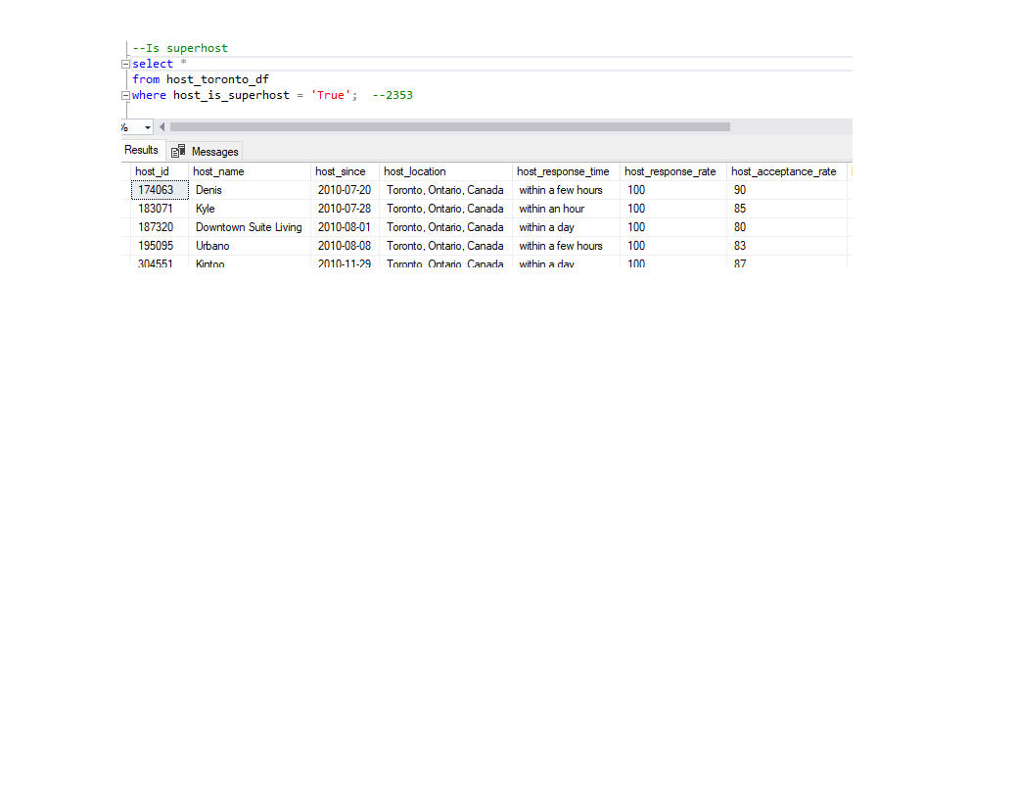

--Review Score

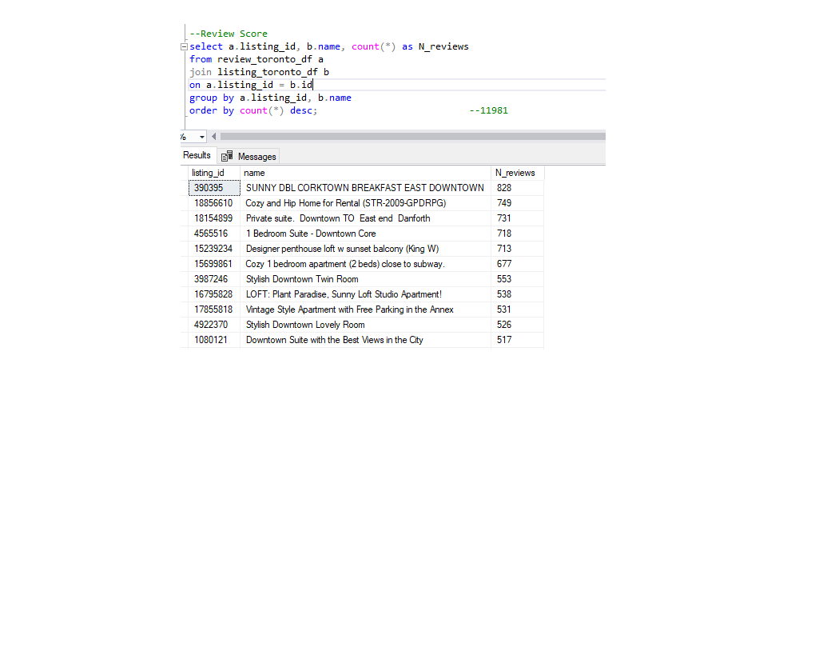

--Bookings per month

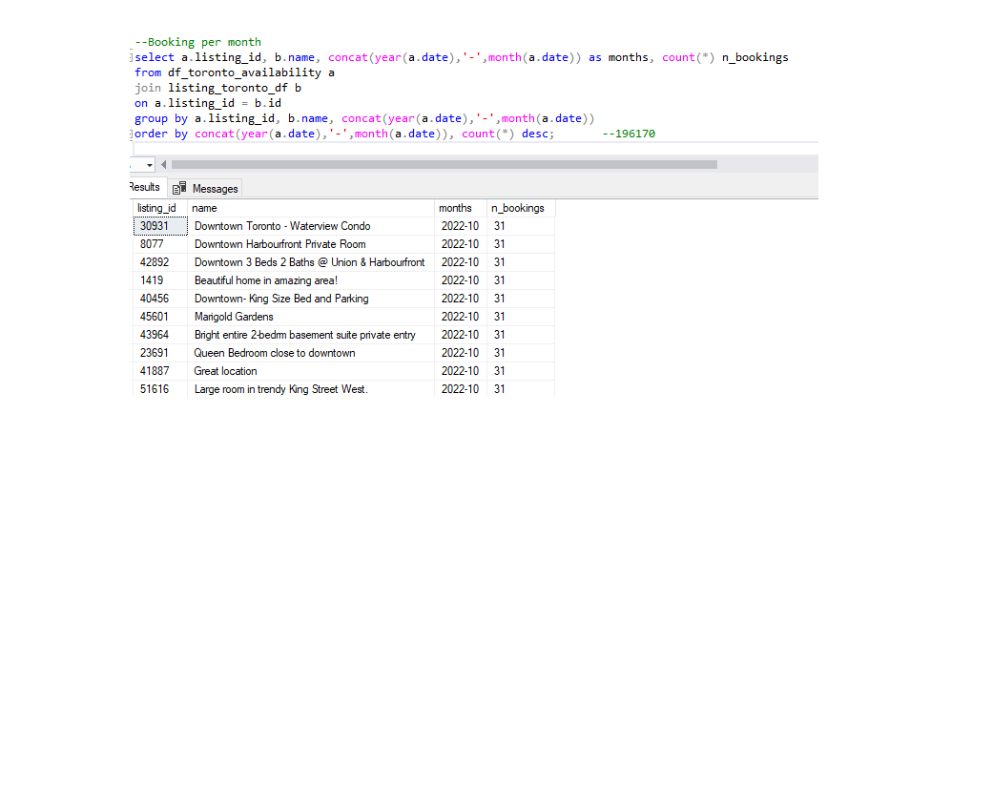

b. Using the above analysis, identify top 3 crucial metrics one needs to maintain to become a

Super Host and also, find their average values.

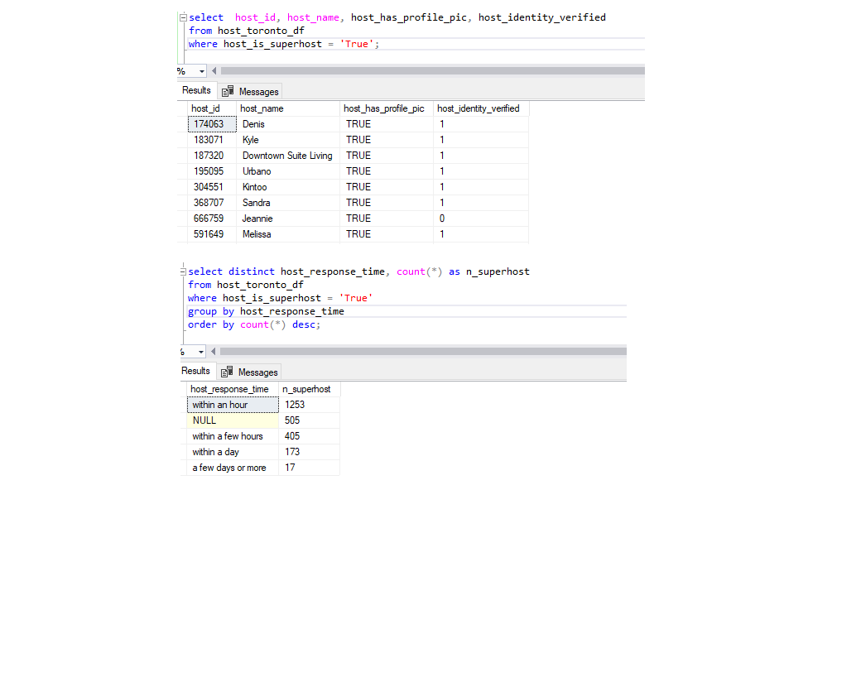

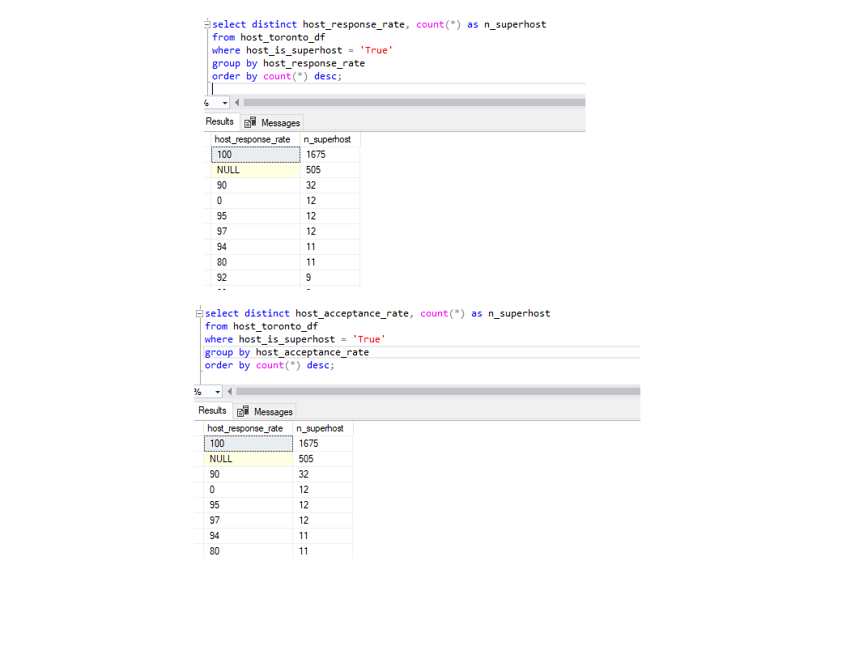

c. Analyse how does the comments of reviewers vary for listings of Super Hosts vs Other Hosts

(Extract words from the comments provided by the reviewers)

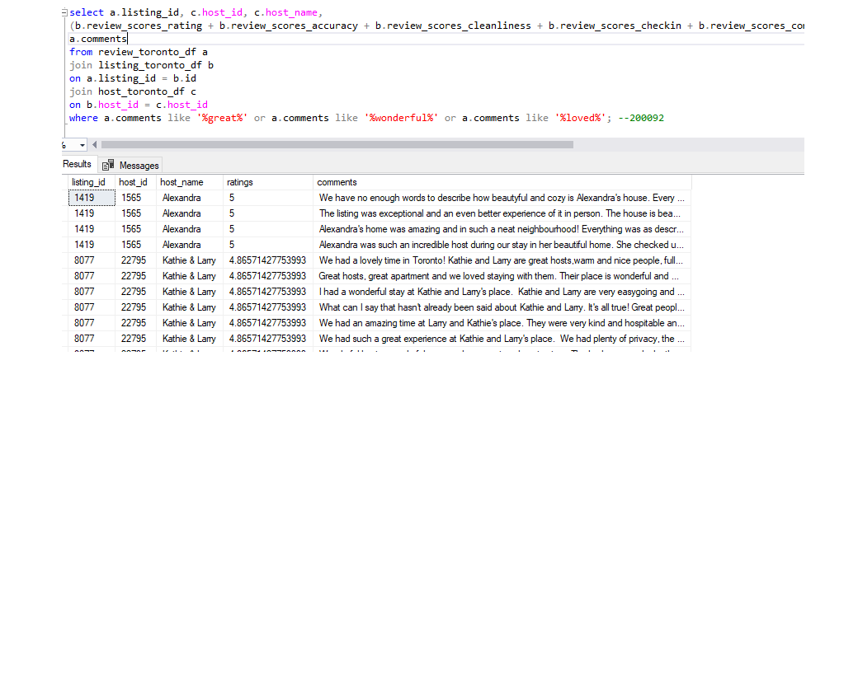 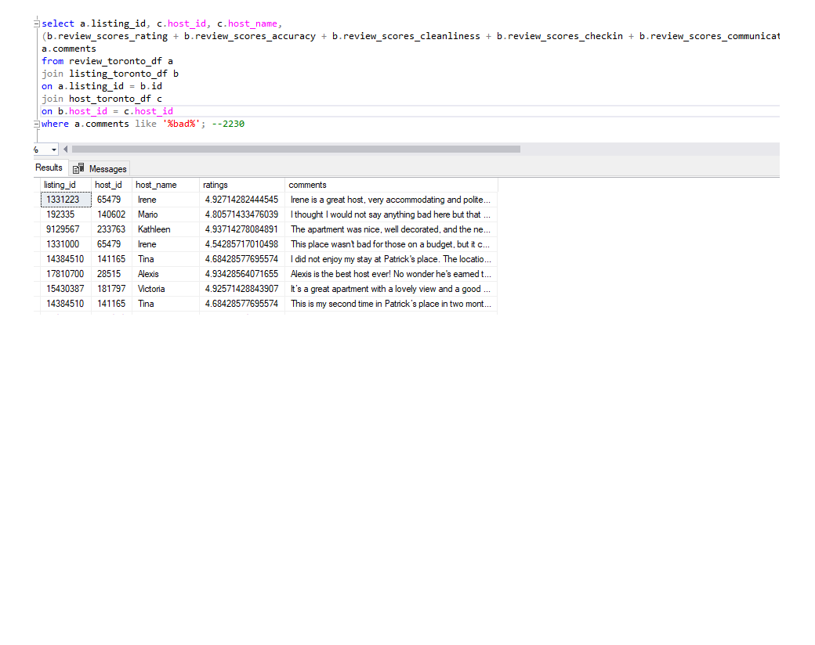

d. Analyse do Super Hosts tend to have large property types as compared to Other Hosts.

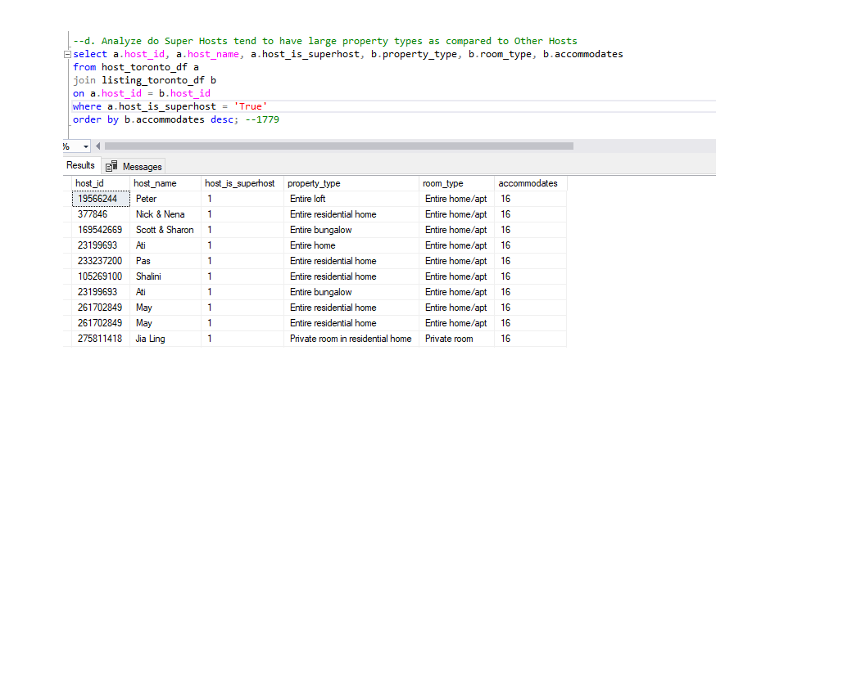

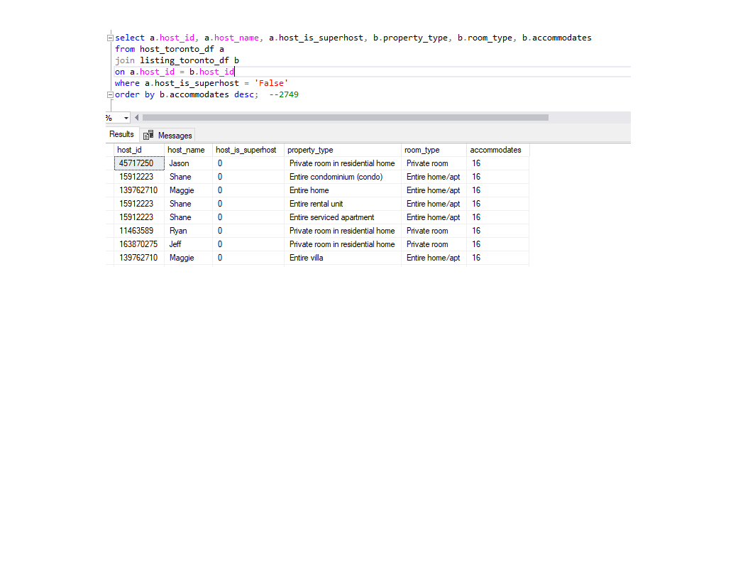

Observation: Cannot say that super hosts hold large properties.

e. Analyse the average price and availability of the listings for the upcoming year between Super

Hosts and Other Hosts. 